Group Members: |  | Project Title:

Chemistry Unit Project – Research

Introduction
Describe the Periodic Table:

How was the Periodic Table created?

What is the Periodic Table used for?

Group Description
Describe the characteristics and trends of your Periodic Table Group.

Group Element One: _________________________________________

Physical Properties
State at room temperature (solid, liquid or gas): _________________
Melting Point (°C): |  |  | Boiling Point (°C):

Conduction of heat: ________________________________________________________________
Conduction of electricity: ____________________________________________________________

Chemical Properties
Reactivity (with chemical examples such as iron reacting with oxygen to form iron oxide/rust):

History & Uses
History of the elements discovery:

Where it’s found:

How we get it:

Common uses (1 historical and 2 modern with examples):

Diagrams
3D Model (Ball & Stick)
Bohr Model
Atomic Information
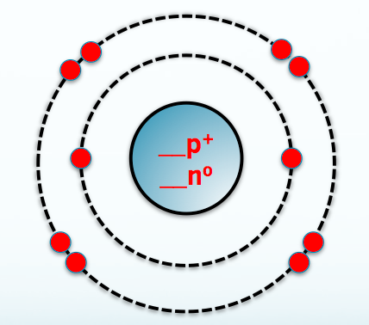
Symbol: _____
Protons: _____
Neutrons: _____
Electrons: _____
Mass: _____

Group Element Two: _________________________________________

Physical Properties
State at room temperature (solid, liquid or gas): _________________
Melting Point (°C): |  |  | Boiling Point (°C):

Conduction of heat: ________________________________________________________________
Conduction of electricity: ____________________________________________________________

Chemical Properties
Reactivity (with chemical examples such as iron reacting with oxygen to form iron oxide/rust):

History & Uses
History of the elements discovery:

Where it’s found:

How we get it:

Common uses (1 historical and 2 modern with examples):

Diagrams
3D Model (Ball & Stick)
Bohr Model
Atomic Information
Symbol: _____
Protons: _____
Neutrons: _____
Electrons: _____
Mass: _____

Group Element Three: _________________________________________

Physical Properties
State at room temperature (solid, liquid or gas): _________________
Melting Point (°C): |  |  | Boiling Point (°C):

Conduction of heat: ________________________________________________________________
Conduction of electricity: ____________________________________________________________

Chemical Properties
Reactivity (with chemical examples such as iron reacting with oxygen to form iron oxide/rust):

History & Uses
History of the elements discovery:

Where it’s found:

How we get it:

Common uses (1 historical and 2 modern with examples):

Diagrams
3D Model (Ball & Stick)
Bohr Model
Atomic Information
Symbol: _____
Protons: _____
Neutrons: _____
Electrons: _____
Mass: _____

Group Element Four: _________________________________________

Physical Properties
State at room temperature (solid, liquid or gas): _________________
Melting Point (°C): |  |  | Boiling Point (°C):

Conduction of heat: ________________________________________________________________
Conduction of electricity: ____________________________________________________________

Chemical Properties
Reactivity (with chemical examples such as iron reacting with oxygen to form iron oxide/rust):

History & Uses
History of the elements discovery:

Where it’s found:

How we get it:

Common uses (1 historical and 2 modern with examples):

Diagrams
3D Model (Ball & Stick)
Bohr Model
Atomic Information
Symbol: _____
Protons: _____
Neutrons: _____
Electrons: _____
Mass: _____

Group Element Five: _________________________________________

Physical Properties
State at room temperature (solid, liquid or gas): _________________
Melting Point (°C): |  |  | Boiling Point (°C):

Conduction of heat: ________________________________________________________________
Conduction of electricity: ____________________________________________________________

Chemical Properties
Reactivity (with chemical examples such as iron reacting with oxygen to form iron oxide/rust):

History & Uses
History of the elements discovery:

Where it’s found:

How we get it:

Common uses (1 historical and 2 modern with examples):

Diagrams
3D Model (Ball & Stick)
Bohr Model
Atomic Information
Symbol: _____
Protons: _____
Neutrons: _____
Electrons: _____
Mass: _____

