Multiple Choice – Magnetism & Electricity
Circle the letter of the best answer.

- At the center of every atom is a core called a(n)
  - element
  - nucleus
  - electron
  - proton

- What effect does the solar wind have on Earth’s magnetic field?
  - Compasses on Earth stop working.
  - It shapes the Earth’s magnetosphere.
  - The magnetic field on the side facing the sun is warmer.
  - Solar wind causes magnetic declination.

- Where on a magnet is the magnetic force the strongest?
  - at the north pole only
  - at either pole
  - halfway between the poles
  - the force is equally strong everywhere

- Magnetic field lines
  - never cross
  - cross at the north pole
  - cross at the south pole
  - cross halfway between the poles

- If you break a magnet in two, you get
  - one north magnet and one south magnet
  - two demagnetized pieces of metal
  - two smaller magnets
  - two magnets each with only one pole

- The amount of magnetic declination depends on…
  - what kind of compass you have
  - what time of the year it is
  - the amount of natural magnets around you
  - your location on Earth’s surface

- The smallest particle of an element that has the properties of that element is a(n)
  - proton
  - domain
  - atom
  - nucleus

- A permanent magnet is a magnet made from a material that
  - keeps its magnetism for a long time
  - cannot be destroyed by heat
  - easily loses its magnetism
  - began as molten rock on the ocean floor

- What is a material called that attracts iron and materials that contain iron?
  - domain
  - aurora
  - magnetic field
  - magnet

- The magnetosphere is the
  - glowing region in the atmosphere caused by charged particles
  - stream of charged particles flowing from the sun
  - doughnut-shaped region 25,000 kilometers above Earth’s surface
  - region of Earth’s magnetic field shaped by the solar wind
- When an atom has an equal number of protons and electrons, the charge of the atom is
  - positive
  - negative
  - neutral
  - static

- The third prong of an appliance is connected to
  - the line coming from the electric plant
  - the ground
  - the line going to the electric plant
  - a circuit breaker or fuse

- What is a substance that conducts electric current in an electrochemical cell?
  - electrode
  - electrolyte
  - insulator
  - voltmeter

- The difference in electrical potential energy between two places is called
  - resistance
  - friction
  - induction
  - voltage

- Charges flow from
  - higher to lower electric potential energy
  - lower to higher electric potential energy
  - higher to lower electric resistance
  - lower to higher electric resistance
- According to Ohm’s law, if there is a constant current in a circuit and the voltage increases, resistance
  - depends on the current
  - decreases
  - increases
  - stays the same

- If the current through a circuit is 2 A and the resistance of a light bulb in the circuit is 10 Ω, what is the voltage difference across the light bulb?
  - 5 V
  - 12 V
  - 0.2 V
  - 20 V

- In a series circuit, if more light bulbs are added, the bulbs become
  - dimmer
  - brighter
  - hotter
  - more resistant

- What extends around a charged object?
  - static electricity
  - electric field
  - electric current
  - power

- The unit of current is the
  - volt
  - amp
  - ohm
  - electron

Fill in the Blank – Magnetism & Electricity
Select the term that best completes the statement.

- A compass can be used to find directions because its needle lines up with Earth’s _________________ poles.

- In a(n) ______________ circuit, all parts are connected one after another along one path.

- The type of electrochemical cell used as an energy source in a flashlight is a(n) _________________.

- In a(n) ____________________ circuit, the different parts of the circuit are on separate branches.

- The type of electrochemical cell found in automobile batteries is a(n) _______________.

- Alessandro Volta constructed the first ________________ out of layers of silver, zinc, and paper soaked in salt water.

- The transfer of electrons from one part of an object to another, caused by the electric field of another object, without them touching is called ___________________.

- A battery transforms ____________________________ into electrical energy.

- The transfer of charge when electrons move from a charged object to another object by direct contact is called ____________________.

- A(n) ______________________ is a region around a charged object where the object’s electric force is exerted on other charged objects.

- The loss of static electricity as electric charges transfer from one object to another is called ____________________________.

- The magnetic force exerted in the region around a magnet is known as it _______________________.

- The transfer of charge from one object to another by rubbing is called _____________.

- A(n) _______________________, such as a battery, creates a potential energy difference in a circuit.

- The ______________________ is a stream of electrically charged particles flowing at high speeds from the sun.

- The buildup of charges on an object is called __________________________.

- In a(n) _______________ circuit, there is only one path for the current to take.

- ________________________________ is the angle between geographic north and the north to which a compass needle points.

- A connection that allows current to take the path of least resistance is a(n) _____________________.

- A(n) ________________________ is a reusable safety switch that breaks the circuit when the current gets too high.

True or False – Magnetism & Electricity
Write True if the statement is true; if the statement is false write False and the correct word to make the statement true.
_______________ | - The force of attraction or repulsion between magnetic poles is called magnetic domain.
_______________ | - Heating a magnet will destroy its magnetism.
_______________ | - Usually in the outer region of an atom are tiny particles called protons, which carry a negative charge.
_______________ | - A permanent magnet is made from a material that easily loses its magnetism.
_______________ | - A material that shows strong magnetic properties is said to be a ferromagnetic material.
_______________ | - A voltmeter is a combination of two or more electrochemical cells in a series.
_______________ | - Voltage causes current in an electric circuit.
_______________ | - In a parallel circuit, there are several paths for the current to take.
_______________ | - Electric current is the attraction or repulsion between electric charges.
_______________ | - A circuit breaker is a safety device that contains a thin strip of metal that melts if there is too much current through it.

Matching – Magnetism & Electricity
Match each term with its definition by writing the letter of the correct definition in the right column on the line beside the term in the left column.
_____ | - ferromagnetic material | - A material that shows strong magnetic effects.
_____ | - nucleus | - A particle that does not carry an electric charge.
_____ | - temporary magnet | - The smallest particle of an element that has all the properties of that element.
_____ | - resistance | - The measure of how difficult it is for charges to flow through a material.
_____ | - neutron | - A tiny, negatively charged particle that usually exists in the outer region of an atom.
_____ | - permanent magnet | - One of about 100 basic materials that make up all matter.
_____ | - proton | - A complete, unbroken path through which electric charges can flow.
_____ | - electric current | - Another name for potential difference.
_____ | - voltage | - The core at the center of every atom.
_____ | - insulator | - Device that creates a potential difference through which electric charges can flow.
_____ | - voltage source | - A positively charged particle found in the nucleus.
_____ | - element | - A magnet made from a material that easily loses its magnetism.
_____ | - electron | - Material through which charge cannot easily flow.
_____ | - electric current | - The continuous flow of electric charges through a material
_____ | - conductor | - A magnet made of a material that keeps its magnetism.
_____ | - magnetic domain | - Material through which charge can easily flow.
_____ | - atom | - A grouping of atoms that have their magnetic fields line up in the same direction.

Interpreting – Magnetism & Electricity
Using the diagram, answer the following questions in the spaces provided.
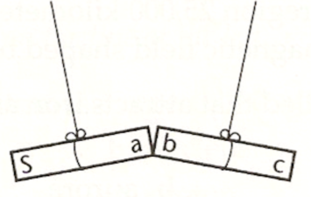
- How should poles a and b be labeled? Explain your answer.
______________________________________________________________________________________________________________________________________________________

- How should pole c be labeled? Explain your answer.
______________________________________________________________________________________________________________________________________________________

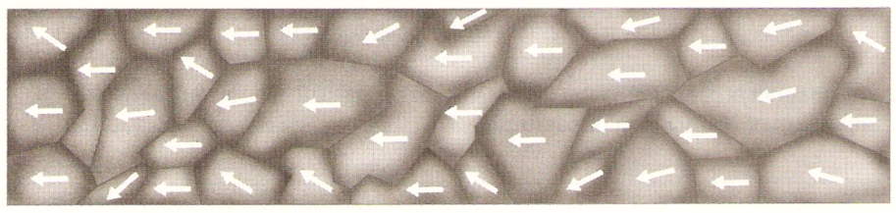

- What do the arrows represent in the figure?
___________________________________________________________________________

- Is this material magnetized or unmagnetized? How do you know?
______________________________________________________________________________________________________________________________________________________

- How might this figure be different if the material shown were hit very hard or heated?
______________________________________________________________________________________________________________________________________________________

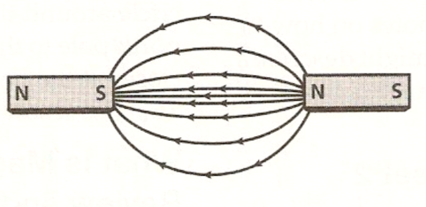

- Where is the magnetic field strongest? How can you tell?
______________________________________________________________________________________________________________________________________________________

- Infer the likely arrangement of magnetic domains in these magnets.
______________________________________________________________________________________________________________________________________________________

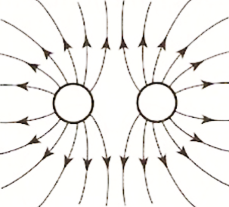

- The charged particle on the left is a proton. What is the charged particle on the right? How do you know?
______________________________________________________________________________________________________________________________________________________

- Explain how this illustration would be different if the charge on the right were the opposite of what it is now.
______________________________________________________________________________________________________________________________________________________

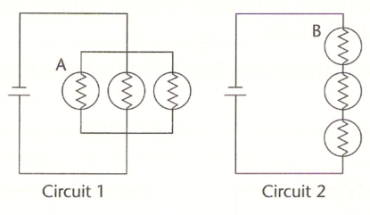
- Which circuit is a series circuit? ____________________

- Which circuit is a parallel circuit? ____________________

- If bulb A burns out, what happens to the light in the other two bulbs in that circuit?
______________________________________________________________________________________________________________________________________________________

- If bulb B burns out, what happens to the light in the other two bulbs in that circuit?
______________________________________________________________________________________________________________________________________________________

- If a fourth bulb were added in a similar way to the three existing bulbs in Circuit 1, what would happen to the bulbs in the circuit?
______________________________________________________________________________________________________________________________________________________

- If a fourth bulb were added in a similar way to the three existing bulbs in Circuit 2, what would happen to the bulbs in the circuit?
______________________________________________________________________________________________________________________________________________________

- How many paths can current take in Circuit 1? __________________

- How many paths can current take in Circuit 2? __________________

- Why does an open light switch turn off the light?
______________________________________________________________________________________________________________________________________________________

- How does direct current differ from alternating current?
______________________________________________________________________________________________________________________________________________________

- What factors affect how strong the electric force between two charged objects?
______________________________________________________________________________________________________________________________________________________

- What does Ohm’s law say?
____________________________________________________________________________________________________________________________________________________________________
- What would be an advantage of using an electromagnet to move objects?
____________________________________________________________________________________________________________________________________________________________________
- How do Auroras form?
____________________________________________________________________________________________________________________________________________________________________
- Describe the three ways a static charge can build up.
________________________________________________________________________________________________________________________________________________________________________________________________________________________________________________________________________________________________________________________________________
- Explain how you could use magnets to make a small object appear to float?
________________________________________________________________________________________________________________________________________________________________________________________________________________________________________________________________________________________________________________________________________

Extended – Magnetism & Electricity
- How do scientists know that Earth’s magnetic field has changed over time?
______________________________________________________________________________________________________________________________________________________

- Why do most materials have magnetic properties too weak to be detected easily?
______________________________________________________________________________________________________________________________________________________

- What are the three properties that magnets have?
______________________________________________________________________________________________________________________________________________________

- How can an unmagnetized material be made into a magnet?
______________________________________________________________________________________________________________________________________________________

- Describe how domains in a magnetized material differ from those in an unmagnetized material.
______________________________________________________________________________________________________________________________________________________

- If you follow a compass pointing north, will you reach the geographic north pole? Explain your answer.
______________________________________________________________________________________________________________________________________________________

- Are household circuits connected in series or parallel? What are two advantages of having them connected that way?
______________________________________________________________________________________________________________________________________________________

- What does Ohm’s law say?
______________________________________________________________________________________________________________________________________________________

- Explain what scientists think causes Earth’s Magnetic Field.
_____________________________________________________________________________________________________________________________________________________________________________________________________________________________________________

- Describe three ways a static charge can build up.
_________________________________________________________________________________________________________________________________________________________________________________________________________________________________

- When wires are connected to the terminals of a battery, what causes electric current in the circuit?
______________________________________________________________________________________________________________________________________________________

- What are two ways that you could alter a wire to increase the resistance in an electric circuit?
______________________________________________________________________________________________________________________________________________________

- What was Alessandro’s first battery composed of?
______________________________________________________________________________________________________________________________________________________

- How does an electrochemical cell produce current in a circuit?
______________________________________________________________________________________________________________________________________________________

- Suppose an automobile battery has three 2-volt cells. What is the total voltage of the battery? Explain.
______________________________________________________________________________________________________________________________________________________

- Explain how Earth is similar to a giant bar magnet and how it is different. Use words and diagrams in your explanation. Remember to explain the difference between the Earth’s geographic poles and its magnetic poles.
_________________________________________________________________________________________________________________________________________________________________________________________________________________________________________________________________________________________________________________________________________________________________________________________________________________________________________________________________________________________________________________________________________________________________________

- In a table, list the features of series and parallel circuits.

