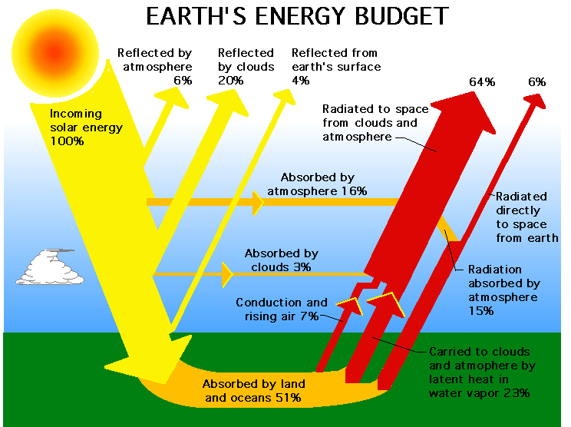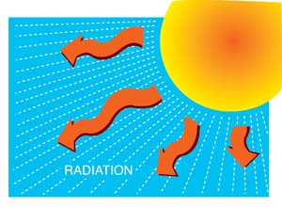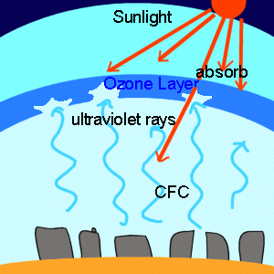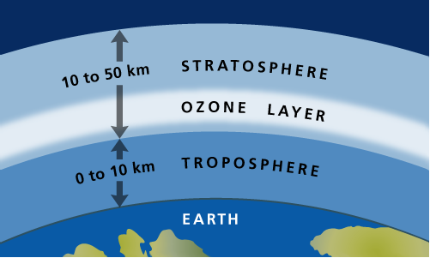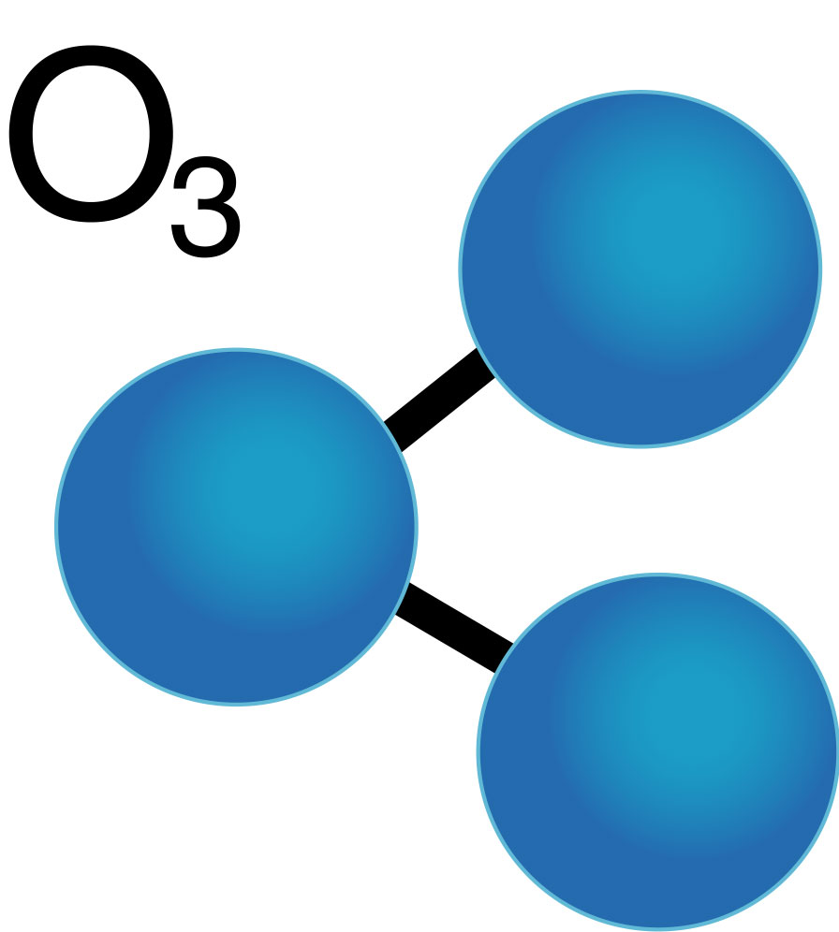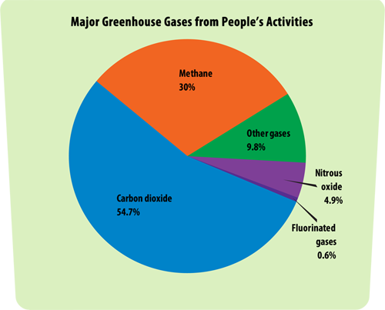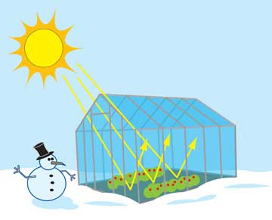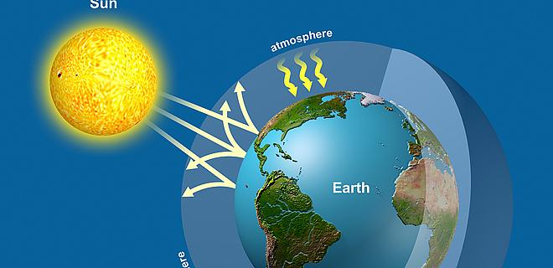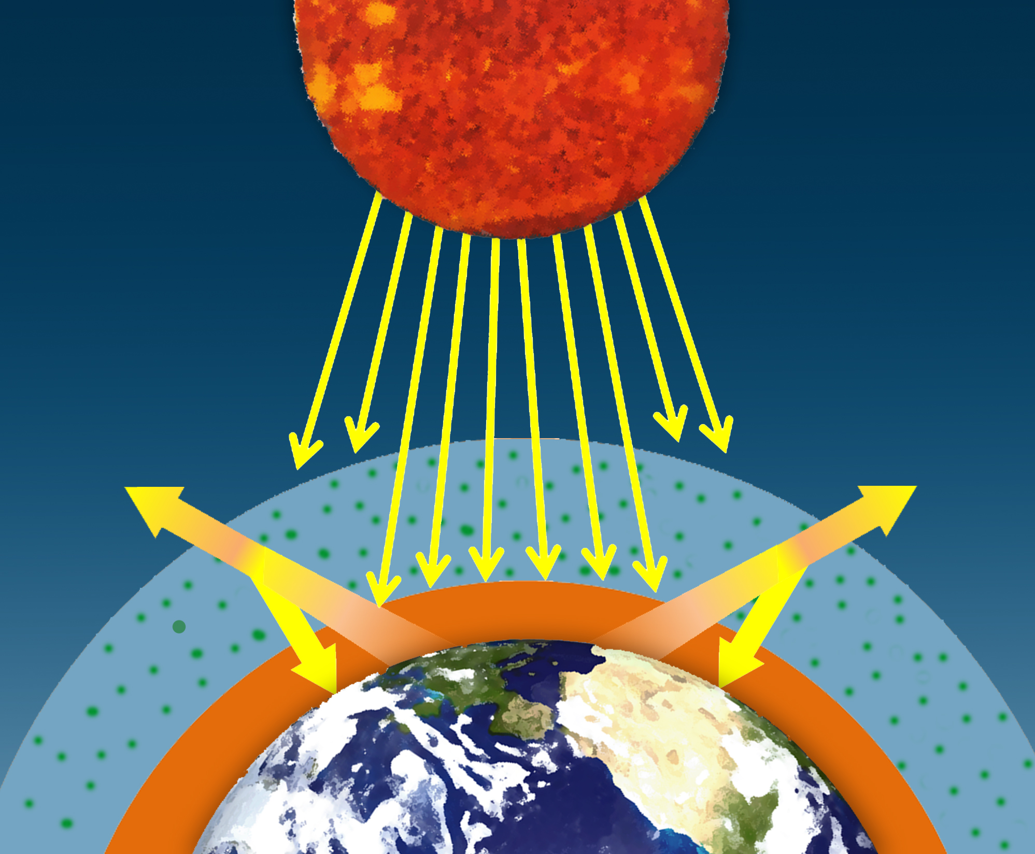

Infrared vs. Ultraviolet

Just as there are sounds humans cannot hear, there are forms of radiation that humans cannot see. Waves of ultraviolet radiation have more energy than the light that you can see. It can cause sunburn and other types of damage. On the other hand, Waves of infrared radiation have less energy than visible light. It usually warms the materials that absorb it. Different gases in the atmosphere absorb these two different types of radiation.

Gases can absorb and give off radiation

On a sunny day, things around you look bright. That is because Earth’s atmosphere reflects or absorbs some sunlight, but allows most of the visible light to pass through to earth’s surface.

A cloudy day is darker because clouds reflect and absorb much of the sunlight, so less light passes through.

The atmosphere can affect light in four ways:

* Absorb light
* Reflect light
* Let it pass through
* Give off light

Backup information:

* Solar radiation heats up Earth’s atmosphere and surface.
* The Ozone layer is in the stratosphere.
* Earth’s surface and atmosphere give off radiation.

Lesson 1.3 – Gases in the Atmosphere Absorb Radiation

*Ozone is a gas molecule (O3) that consists of three oxygen atoms.* Our body uses regular oxygen (O2), which has two atoms of oxygen.

In the stratosphere, ozone and regular oxygen gases break apart and form again in a complex cycle. The ozone in the stratosphere is called the ozone layer. The ozone layer protects life from harmful ultraviolet radiation from the sun.

Too much ultraviolet radiation can cause sunburn, cause cancer, and damage eyesight. Ultraviolet radiation can also harm crops and materials such as plastic or paint.

Ozone absorbs ultraviolet radiation but lets other type of radiation, such as light, pass through.

The ozone layer protects life from harmful radiation

Greenhouse effect

There are certain gases in the atmosphere that slow the movement of energy away from Earth’s surface. These gases absorb and give off infrared radiation, which keeps the energy flowing in the Earth’s surface. This process is the greenhouse effect, and it was named that way because it reminded scientists of the way glass traps the warmth in a greenhouse.

Greenhouse gases

*Gases, such as carbon dioxide and methane, that absorb and give off infrared radiation as part of the greenhouse effect, are called* greenhouse gases. There are many greenhouse gasses, some are:

1. Carbon Dioxide
2. Methane
3. Water Vapor
4. Nitrous oxide

Greenhouse gases are mixed together with nitrogen, oxygen, and other gases in the air. Also, these gases do not form a single layer in the atmosphere. Since the atmosphere is densest in the troposphere, then that is where most greenhouse gas molecules are.

The greenhouse effect keeps earth warm

How does the greenhouse effect work?

Greenhouse gases absorb the infrared radiation gave by the Earth.

Some of the energy is absorbed by the surface, and some energy goes to space thus keeping earth warmer.

Radiation from the sun warms earth’s surface, then gives off infrared radiation. If there were no greenhouse gases, the infrared radiation would go straight through the atmosphere into outer space. At that moment, water would freeze, and it would be too cold for most forms of life to survive at earth.

Atmosphere with greenhouse gases:

Average Temperature: 15 ℃

Radiation from Earth’s surface is lost slowly, making the Earth’s surface warmer.

Atmosphere without greenhouse gases:

Average Temperature: -18 ℃

Radiation from earth’s surface is lost directly to space.

The Greenhouse Effect

T