Chemistry Key Concepts
Circle the letter of the best answer.

- An example of a chemical property of a substance is
  - size
  - melting point
  - shape
  - flammability

- Which of the following is a physical property of an element?
  - color
  - ability to rust
  - flammability
  - ability to tarnish

- Every chemical or physical change in matter includes a change in
  - volume
  - temperature
  - energy
  - mass

- A measure of the amount of matter in an object is its
  - mass
  - density
  - volume
  - length

- A block of metal has a length of 3 cm, a width of 5 cm, a height of 10 cm, and a mass of 3,000 grams. Find the density of the metal in g/cm³.
  - 20 g/cm³
  - 50 g/cm³
  - 0.5 g/cm³
  - 0.02 g/cm³

- Bromine has atomic number 35. From this information you know that a bromine atom has
  - 35 protons and 35 electrons
  - 35 protons and 35 neutrons
  - 35 electrons and 35 neutrons
  - 35 protons and 7 electrons

- The energy of matter in motion is ______________ energy.
  - electromagnetic
  - potential
  - chemical
  - kinetic

- A cubic centimeter is a unit for measuring
  - length
  - volume
  - mass
  - density

- When water freezes, it undergoes
  - a physical change
  - a chemical change
  - vaporization
  - sublimation

- A(n) __________________ is an example of a homogeneous mixture that is very evenly mixed.
  - compound
  - element
  - pure substance
  - solution

- Which of the following is NOT a characteristic of a compound?
  - has different properties from the elements that formed it
  - pure substance made of two or more elements
  - different samples have different properties
  - can be represented by a chemical formula

- Which of the following is an example of a chemical change?
  - melting butter
  - mixing milk and chocolate syrup
  - breaking glass
  - burning fuel

- A chemical bond is
  - a group of atoms that are joined together
  - the basic particle of matter
  - the force that holds two atoms together
  - a substance formed from the chemical combination of two or more atoms

- The elements in one period of the periodic table
  - have the same number of electrons
  - have the same number of protons
  - decrease in atomic mass from left to right
  - increase in atomic number from left to right

- Which of the following is NOT true of atoms?
  - They are composed of molecules
  - They can combine with other atoms
  - They make up elements
  - They are extremely small

- Which of the following does NOT describe physical properties of metals?
  - malleable
  - good conductivity
  - brittle
  - ductile

- A(n) _______________ is a positively charged particle in an atom’s nucleus.
  - electron
  - neutron
  - plasma
  - proton

- Which of the following is NOT a characteristic of most metals?
  - brittle
  - ductile
  - good conductor
  - malleable

- An element’s properties can be predicted from its
  - number of isotopes
  - number of neutrons
  - atomic mass
  - location in the periodic table

- Where are nonmetals located in the periodic table?
  - in Group 2
  - on the left half of the table
  - in the bottom row
  - to the right of the metalloids

- An element’s _____________ tells the number of protons in its nucleus.
  - atomic mass
  - atomic number
  - chemical symbol
  - period

- One problem of synthetic polymers is their
  - strength
  - inability to break down
  - cost
  - limited use

- Which of the following is NOT a use of radioactive isotopes?
  - improving the strength of metals
  - diagnosing and treating disease
  - tracing the steps of chemical reactions
  - providing sources of energy

- How do crystalline and amorphous solids differ?
  - Crystalline solids do not melt at a distinct temperature
  - Amorphous solids are made up of crystals
  - Crystalline solids have a regular pattern of particles but amorphous solids do not
  - Amorphous solids are always soft

Chemistry - Fill in the Blanks
Fill in the line to complete each statement. (1 point each)

- A(n) _________________________ is a group of atoms that are joined together by chemical bonds.

- An object’s ______________________ is its mass divided by its volume.

- A measure of the average energy of random motion of particles of matter is _____________________.

- A pure substance that cannot be broken down into any other substances by chemical means is called a(n) ___________________________.

- ________________________ is the ability to do work or cause change.

- When elements are chemically combined, they form _____________________, which have properties different from those of the uncombined elements.

- A(n) ______________________ has a definite shape and volume because its particles are packed tightly together and stay in fixed positions.

- The graph for Boyle’s law shows that the pressure of a gas at constant temperature ________________ with its volume.

- Polymers form when chemical bonds link large numbers of small molecules called _________________ in a repeating pattern.

- ______________________ are often used to store food and make roofing tiles because they resist moisture and withstand heat.

- A(n)________________________ is an example of a homogenous mixture that is very evenly mixed.

- An element’s __________________ tells the number of protons in its nucleus.
- Elements in the same__________________ on the periodic table have the same valence (outer shell) electrons.
- The family of ___________________ is the most reactive group of metals in the periodic table.
- The elements in a column are called a group or _____________________.
- Electrons may be anywhere within this _____________ _______________.
- Each horizontal row of the table is called a ________________. It helps us identify the number of shells in a Bohr Model.
- In an ___________________________ , energy is absorbed.
- ____________ is the ability to do work or cause change.
- The law of conservation of mass states that in any chemical or physical change, ______________ is not created or destroyed.

Chemistry - True or False
If the statement is true, write true. If it is false, write false and change the underlined word to make the statement true. (1 point each)
- ________________________ During a chemical change, the form of a substance is altered, but not its identity.

- ________________________ A change in matter in which energy is taken in is an endothermic change.

- ________________________ Electrical energy is the energy of electrically charged particles moving from one place to another.

- ________________________ A solid block that sinks in a container of water has a lower density than water.

- ________________________ Ice is an example of the liquid state of matter.

- ________________________ An objects mass will change if you move it from Earth to the moon.

- ________________________ A motor oil with high viscosity moves through an engine quickly.

- ________________________ The reactivity of metals tends to decrease as you move from left to right across the periodic table.

- ________________________ Inside stars, the pressure is so high that nuclei are packed close together and collide with one another.

- ________________________ Alloys are used more than pure metals because they are generally softer and less likely to react with air or water.

Scientific Method - Math Skills
Use the figures and information to complete the following questions. Show your work. Be sure to use correct units of measurement. (2 points each)
- If 2.2 pounds equals 1 kilogram, and 1 kilogram equals 1000 grams. How many grams are in 5 pounds.

- What is the volume of the solid in the figure? Show your work. Be sure to use correct units of measurement.
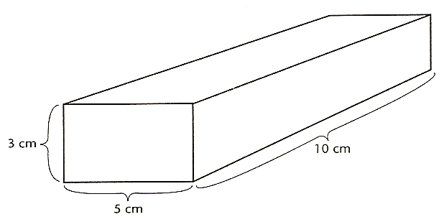

- The solid has a mass of 120 g. What is the density of the solid? Would it sink or float in water?

- Calculate the density of alcohol, if its volume is 12.9 cm³, and you have 10 grams of it.

- Calculate the density of corn syrup if its volume is 7.20 cm³, and you have 10 grams of it.

- Calculate the density of cooking oil if its volume is 10.4 cm³, and you have 10 grams of it.

- Label each layer of liquid in the test tube above using the information on densities that you have calculated for alcohol, corn syrup, cooking oil, and water (given at 1 g/cm³).

Chemistry - Interpreting Diagrams
Use the figures below to answer the following questions in the spaces provided. (2 points each)
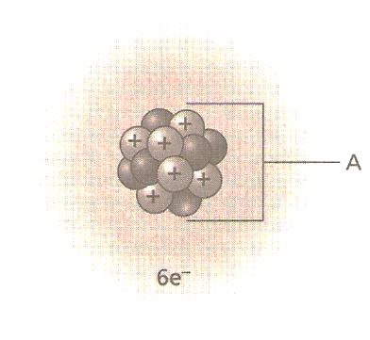
- Name the part of the atom labeled A. What particles make up A?
________________________________________________________________________________________________________________________________________________________________________________

- Does this atom have a neutral electric charge? How can you tell?
________________________________________________________________________________________________________________________________________________________________________________

- Why do elements within a group have similar chemical properties?
________________________________________________________________________________________________________________________________________________________________________________

- What is the atomic number of a sodium atom that has 11 protons and 12 neutrons?
________________________________________________________________________________________________________________________________________________________________________________

- Label each figure as a pure substance or a mixture.

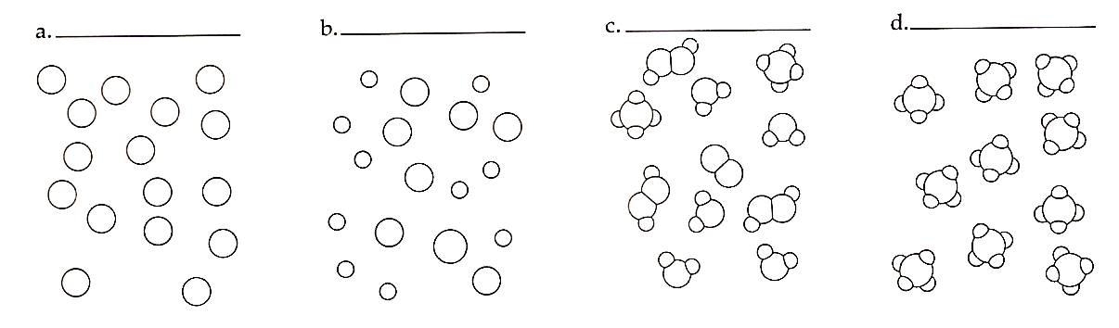

- Is an element or a compound represented in figure (d)? Explain your answer.
________________________________________________________________________________________________________________________________________________________________________________________________________________________________________________________________________________________________________________________________________________________________

Chemistry - Short Answer
Answer each of the following in the spaces provided. (2 points each)

- Explain why weight is NOT considered a constant measurement of the amount of matter an object contains.
________________________________________________________________________________________________________________________________________________________________________________________________________________________________________________________________________

- Compare and contrast an element and a compound.
________________________________________________________________________________________________________________________________________________________________________________________________________________________________________________________________________

- Give an example of a mixture that is a solution, and a mixture that is not a solution. Which mixture is heterogeneous? Explain your answer.
________________________________________________________________________________________________________________________________________________________________________________________________________________________________________________________________________

- An unknown sample of an element is a solid that crumbles easily into a powder and does not conduct electricity. Is this element a metal or a nonmetal? Explain how you know.
________________________________________________________________________________________________________________________________________________________________________________________________________________________________________________________________________

- Explain why the mass of a candle does not disappear while burning.
________________________________________________________________________________________________________________________________________________________________________________________________________________________________________________________________________

- Burning a piece of wood and sawing a piece of wood both make the original piece smaller. What type of change takes place when wood is burned? When wood is cut? Explain your answers.
________________________________________________________________________________________________________________________________________________________________________________________________________________________________________________________________________

Chemistry Essay Questions
Answer the following in the spaces provided. (5 points each)
- Melting ice is a physical change. Heating table sugar until it becomes caramel is a chemical change. Compare and contrast the two types of changes.
________________________________________________________________________________________________________________________________________________________________________________________________________________________________________________________________________________________________________________________________________________________________

- In terms of energy changes, explain how your ability to ride a bike is related to energy from the sun?
________________________________________________________________________________________________________________________________________________________________________________________________________________________________________________________________________________________________________________________________________________________________

- Describe the energy transformations that occur when a person pushes a bike to the top of a hill and coasts down.
________________________________________________________________________________________________________________________________________________________________________________________________________________________________________________________________________________________________________________________________________________________________

- Describe what is happening at a molecular level when water vapor at 110 C is cooled to -10 C.
________________________________________________________________________________________________________________________________________________________________________________________________________________________________________________________________________________________________________________________________________________________________

- Explain what will happen to an inflated balloon that is stored in a refrigerator overnight, and then taken out and allowed to warm to room temperature.
________________________________________________________________________________________________________________________________________________________________________________________________________________________________________________________________________________________________________________________________________________________________

